ReactJS Hands-On Lab
Office Space Rental App using JSX

Objective
The goal of this lab was to build a small React application that uses JSX to create elements and attributes, and renders the DOM to show office space rental listings. Along the way I practiced writing JSX expressions, using object and array data inside JSX, looping through a list with map(), and applying inline/conditional CSS styling based on data values.

What I Did
- Created a new React app named "officespacerentalapp" using create-react-app inside my project folder (10. ReactJS-HOL).
- Added a heading element for the page title using a JSX expression.
- Added an <img> tag with a JSX attribute to display an office space photo.
- Created a JavaScript object to hold a single office's details (Name, Rent, Address) and rendered it using JSX.
- Created an array of office objects and used .map() to loop through them, rendering a card-like block for each office (Name, Rent, Address).
- Wrote a small helper function that checks the Rent value and returns a CSS class name — textRed if Rent is 60000 or below, and textGreen if it is above 60000 — and applied it inline via className.
- Ran the app with npm start and verified the output in the browser at localhost:3000.

1. Project Setup
First, I opened the terminal in VS Code, navigated to my working folder, and scaffolded the app using create-react-app. Below is the terminal after the project was created and I moved into the officespacerentalapp folder.
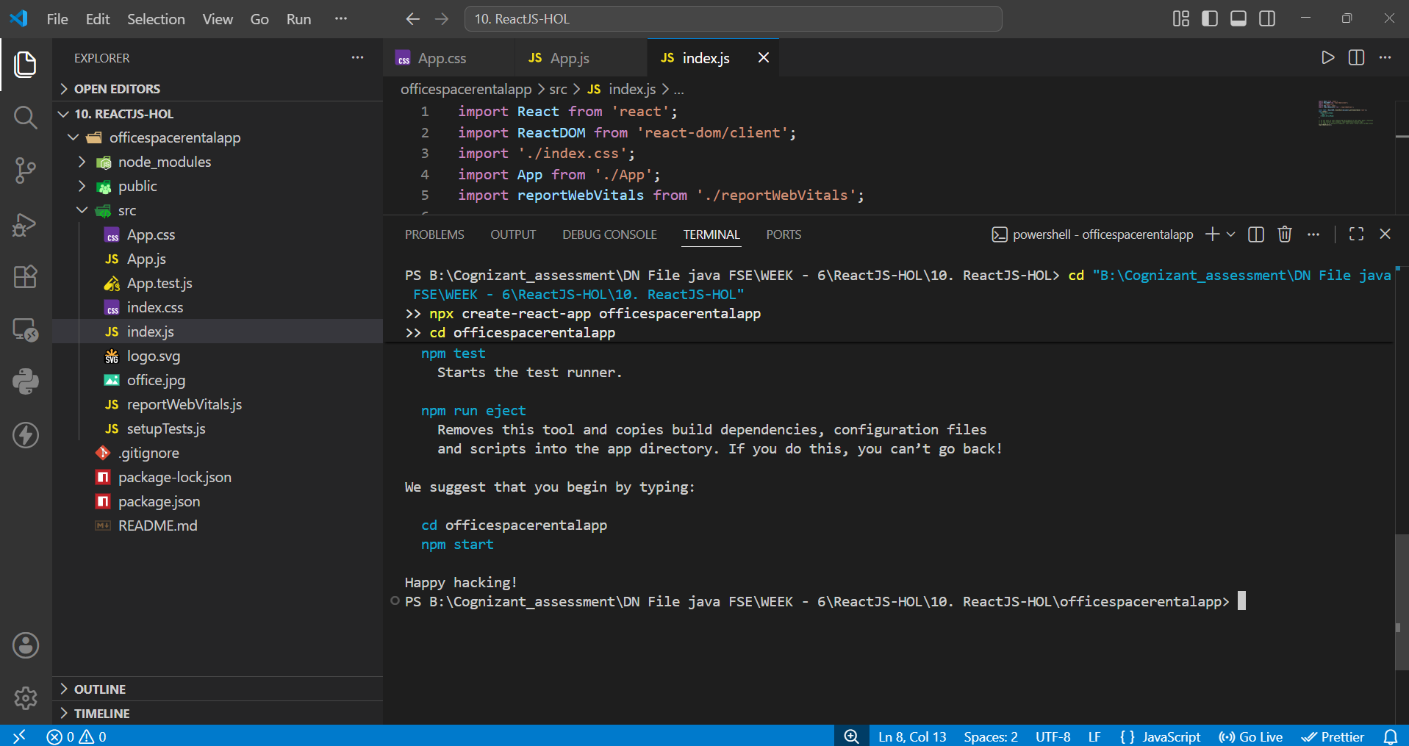
Fig 1: Project created with create-react-app and folder structure in VS Code

2. Running the App
Once the base files (index.js, App.js, App.css, office.jpg) were in place, I started the development server using npm start. The webpack build compiled successfully and the app opened on localhost:3000.
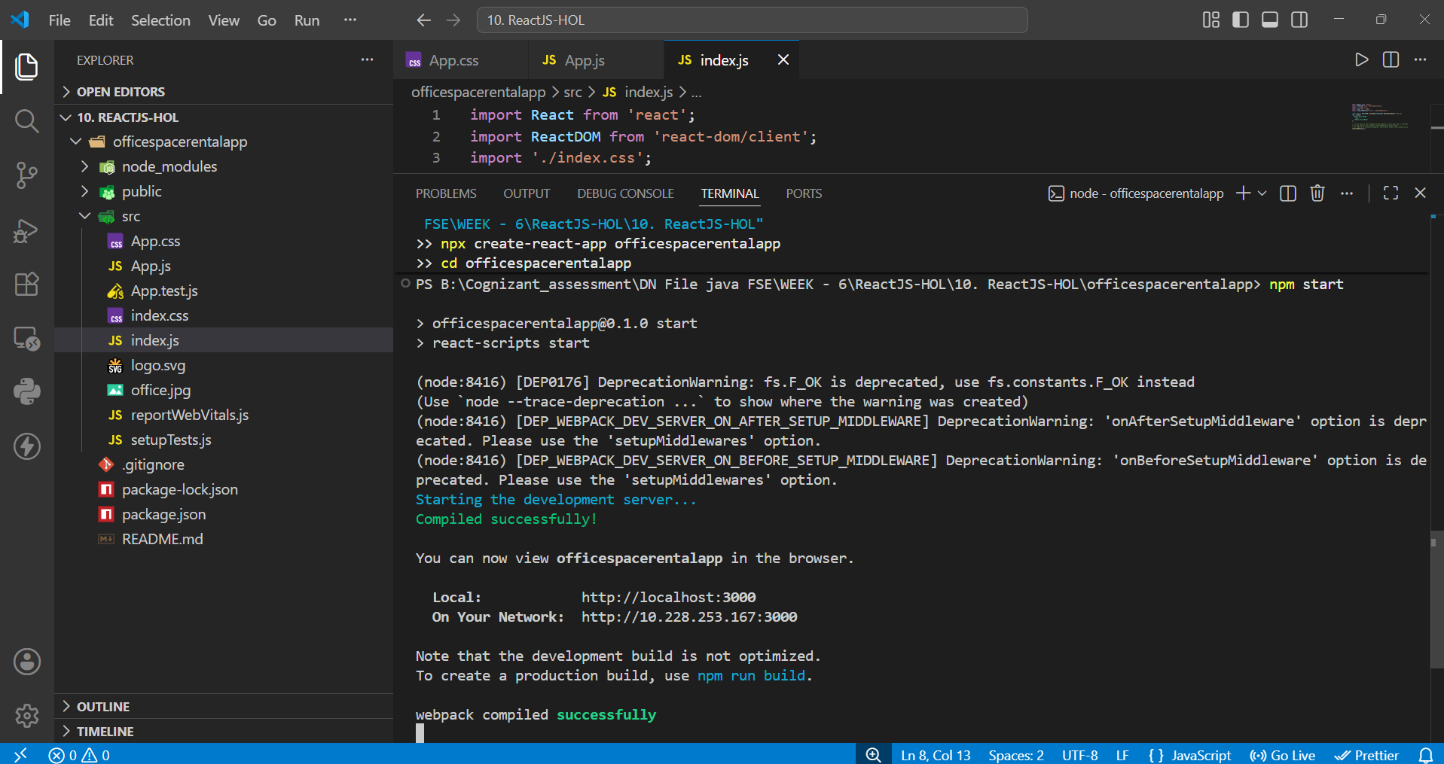
Fig 2: npm start — app compiled successfully and running on localhost:3000

3. Output — Heading, Image and Single Office Object
The first part of the output shows the page heading rendered through a JSX expression, the office image rendered via a JSX attribute (src), and the details of a single office object (Name: DBS, Rent: Rs. 50000, Address: Chennai). Since the rent (50000) is less than or equal to 60000, it is shown in red as expected.
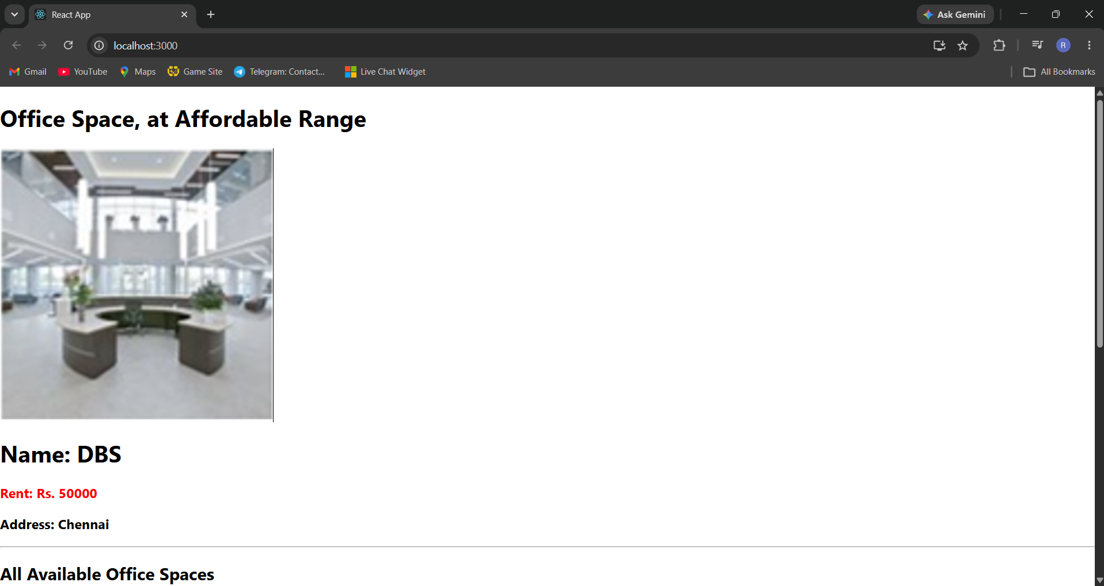
Fig 3: Heading, office image, and single office object rendered on the page

4. Output — List of Offices with Conditional Styling
The second part of the output shows the array of office objects looped through with map(). Each block displays Name, Rent, and Address. The Rent color changes based on the value: DBS (50000) and Infosys (45000) are shown in red since they are 60000 or below, while TCS (65000) and Wipro (72000) are shown in green since they are above 60000. This confirms the conditional CSS logic is working correctly.
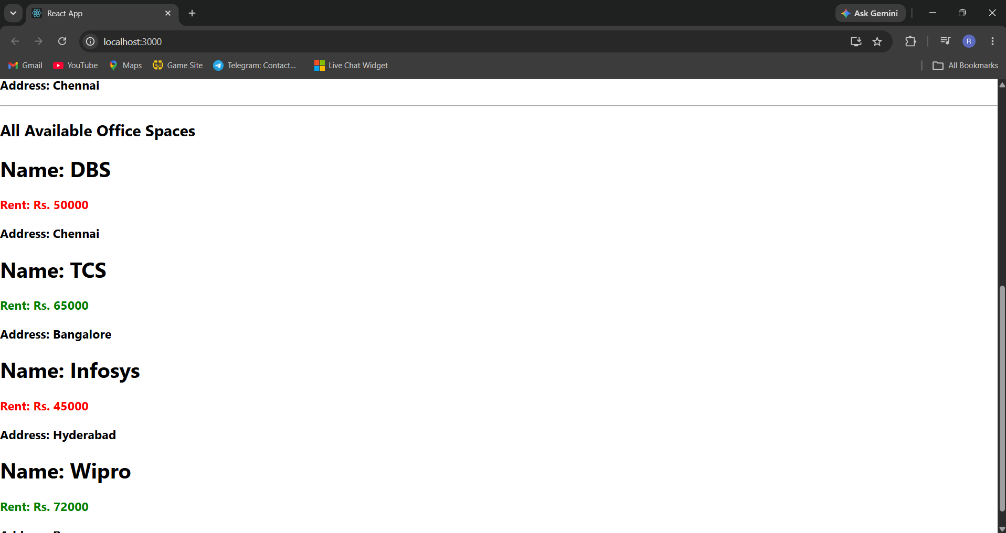
Fig 4: List of all office spaces with Rent shown in red/green based on the value

Conclusion
Through this lab I got hands-on practice with JSX — creating elements, using attributes, embedding JavaScript objects and arrays directly inside markup, looping with map(), and applying conditional inline styling. The final app successfully renders a heading, an office image, and a dynamic list of office spaces with rent-based color coding, matching the expected output.

